实验报告（第七次上机）

电自2003 赵洪

#include<iostream>

//#include<cstring>

#include<cmath>

using namespace std;

class complex {

private:

double real;

double image;

public:

complex(double real1=0 ,double image1=0):real(real1),image(image1){}

friend complex operator\*(complex& x, complex& y);

void show();

};

void complex::show()

{

cout << "The multiplication of the complexes is : " << endl;

cout << real;

if (image > 0)

cout << "+";

if(image!=0)

cout << image << "i" << endl;

}

complex operator\*(complex& x, complex& y)

{

complex temp;

temp.real = x.real \* y.real-x.image\*y.image;

temp.image = x.real \* y.image+x.image\*y.real;

return temp;

}

int main()

{

double x1, x2, y1, y2;

cout << "Please input the first complex: " << endl;

cin >> x1 >> y1;

cout << "Pease input the second complex: " << endl;

cin >> x2 >> y2;

complex a(x1 ,y1);

complex b(x2, y2);

complex c;

c = a \* b;

c.show();

return 0;

}

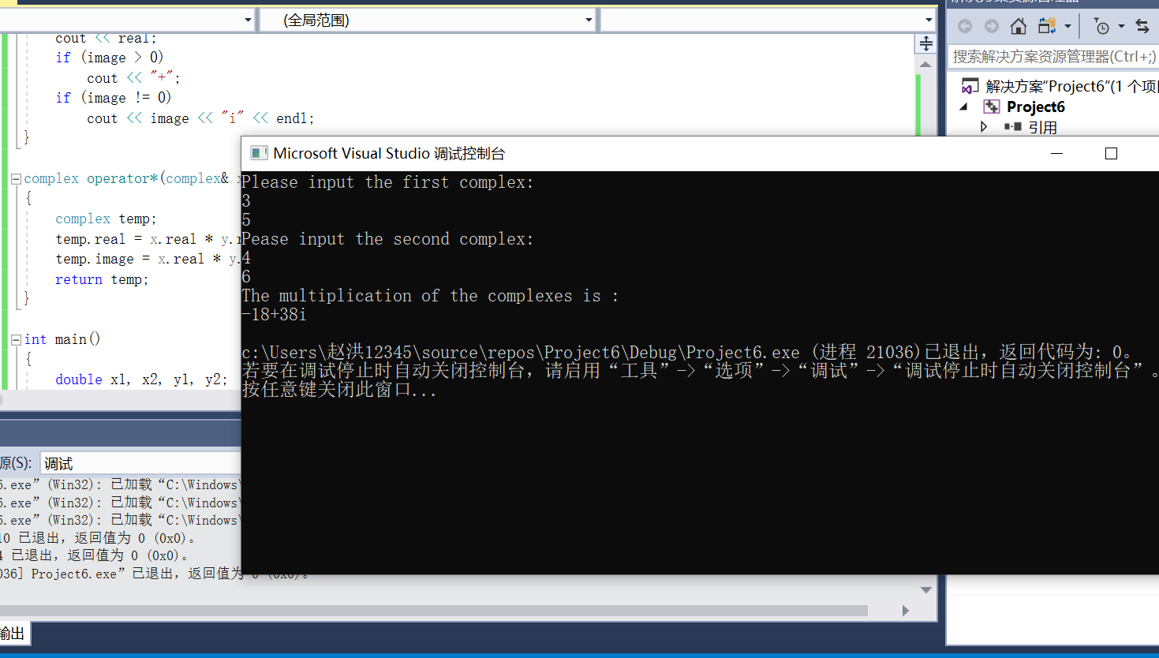

通过本次上机，我初步理解了C++语言多态性的基本概念并掌握运算符重载函数的声明和定义方法。一是直接在类内声明定义：（返回值是本类的对象）；二是在类中声明为友元函数，类外定义，返回值的是一个类的对象。（一般为了能在类外直接调用成员而不用通过成员函数间接调用成员数据）